**This error always appears when I try to use Lag 3 or 4, it doesn't accept lag < 5**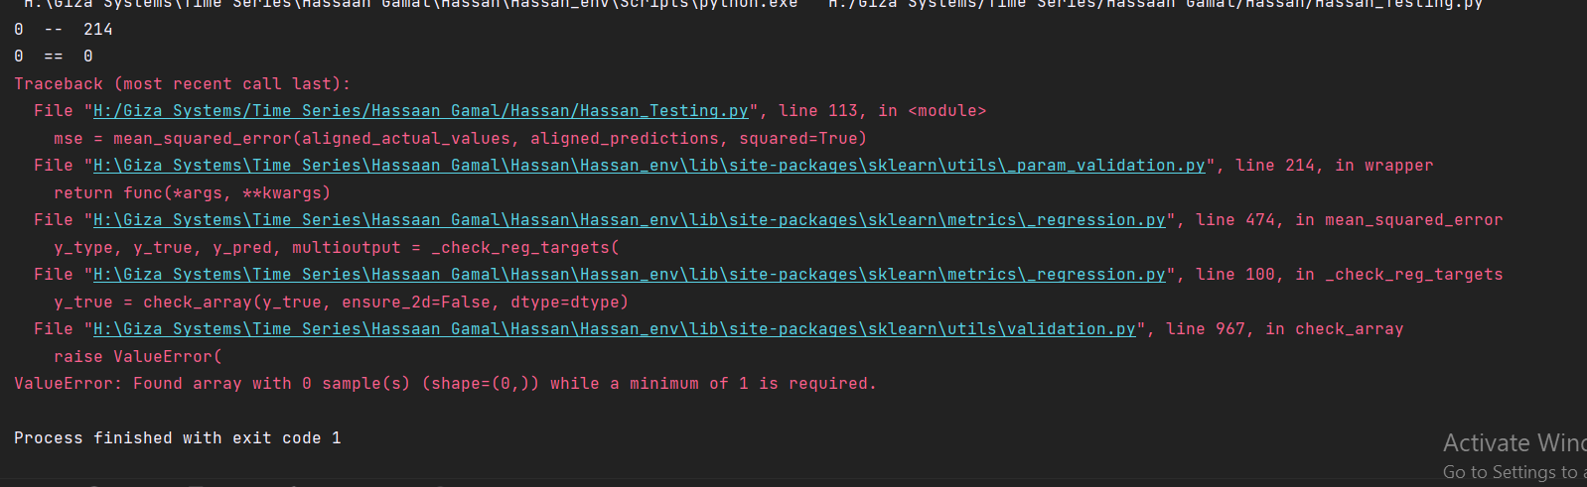

**Handling of missing values:**

The size of the predictions returning from the api is lesser than the actual test, also the actual test have nulls, so we have to adjust both, since the prediction doen’t have nulls I adjusted the data according to the actual test data, I didn't consider taken any nulls from the actual neither the corresponding index of the predicted value to keep consistency.

**"anomaly" column**

This is what happen when I try to send anomaly column in the data

